# **Database Management System**

**Front-End:**

In the front-end part, we have completed sign in and sign up page design.

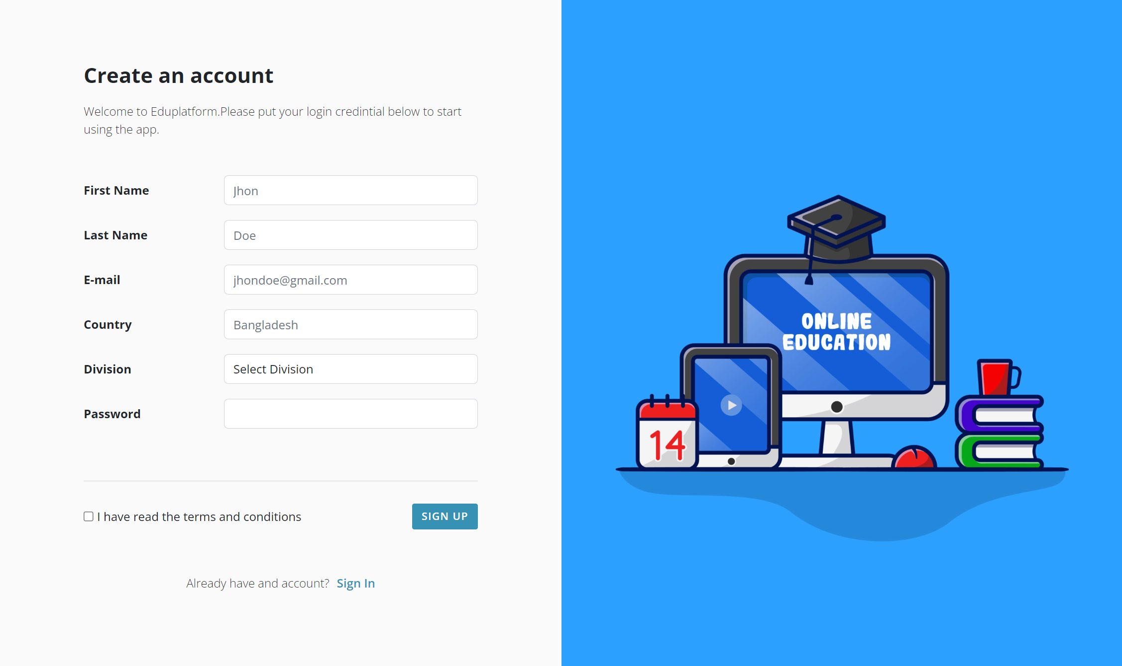 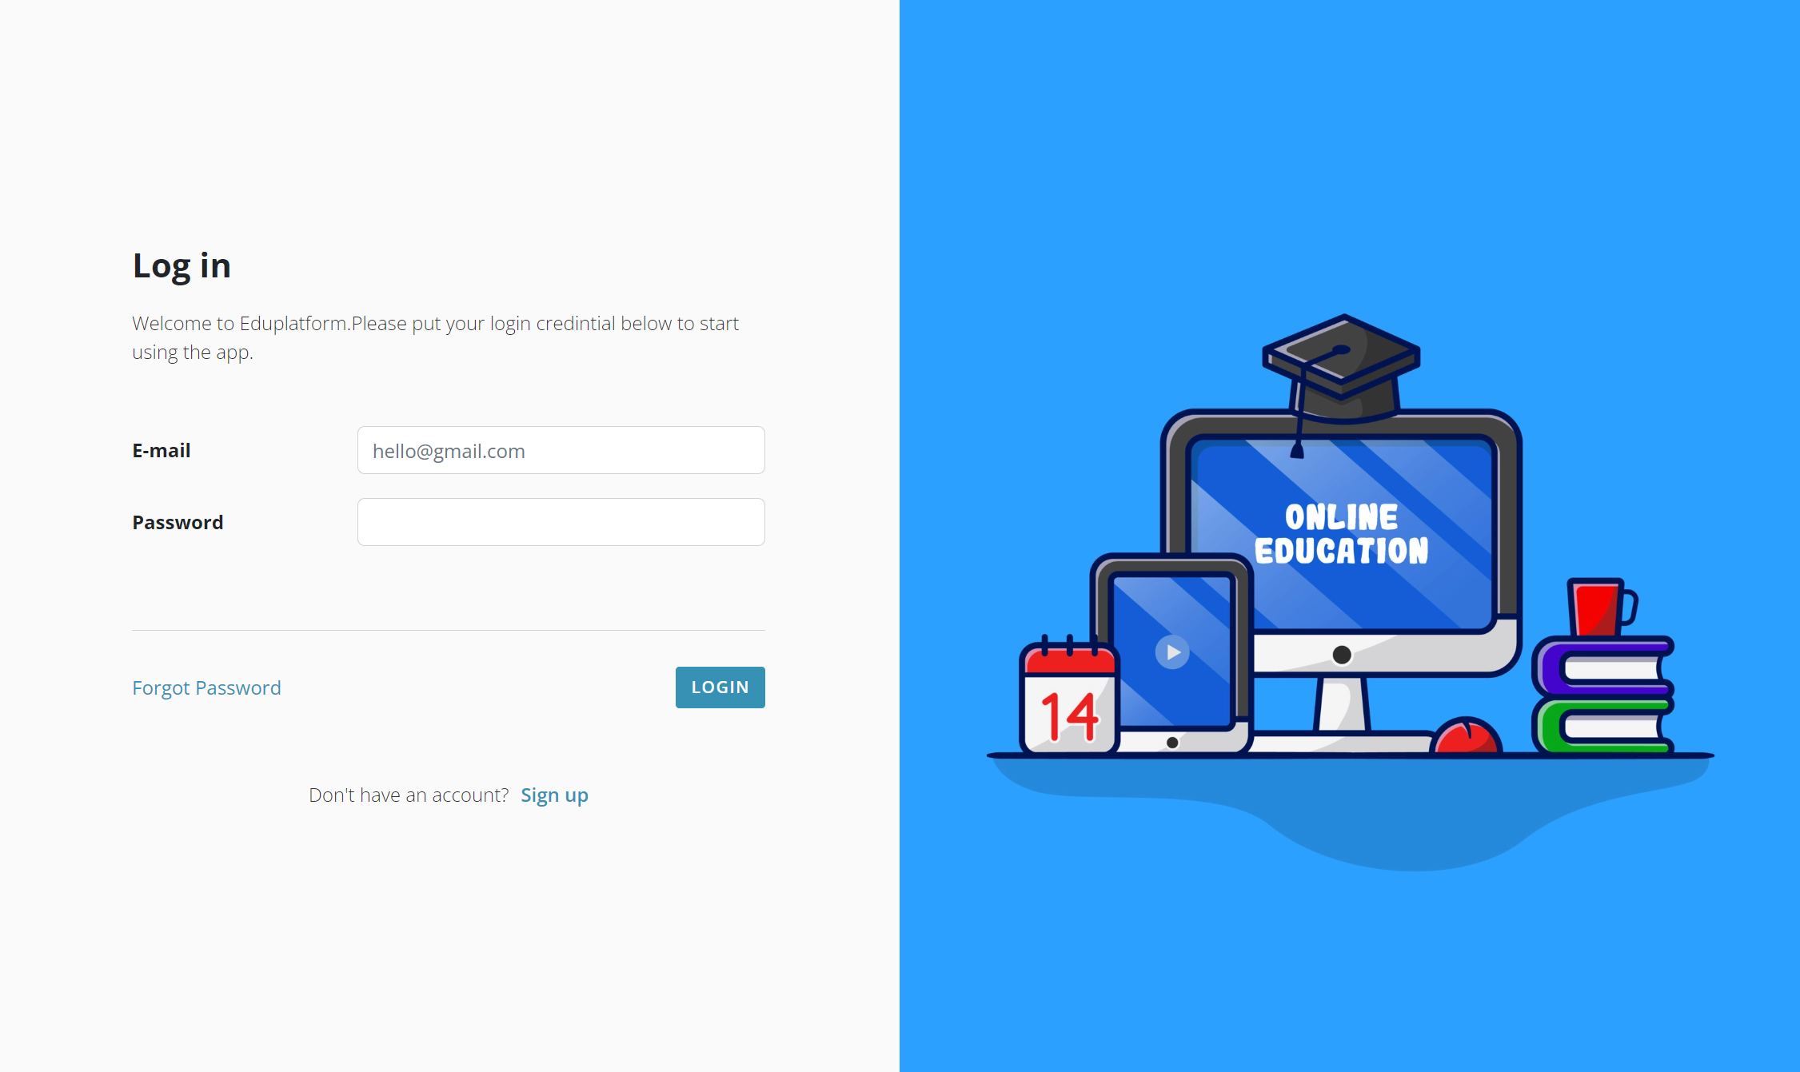

**Back-End:**

In the back-end part, we have created login and registration module and connected to database.

**Database:**

In the database part, we have created login and registration queries.